Deep Learning – Exercise 1
Salomon Benhamo 332651918
Yarden Carmel 208520288

Question 1 – Fully connected neural network
We have a mini-batch of size m. Each sample has 10 input features, there is one hidden layer with 50 neurons and an output layer with 3 neurons. All neurons use ReLU.

Section a - Shape of the input matrix X
$$X∈R^{m×10}$$Each of the m rows is one sample; each row has 10 input features.

Section b - Shapes of the hidden layer parameters
Let $W^{\left(h\right)}$ be the weight matrix of the hidden layer and $b^{\left(h\right)}$ its bias.
$$W_{h}∈R^{10×50}$$$b_{h}∈R^{1×50}$
The input size is 10 and the hidden layer output size is 50. The weight matrix maps the input features to the hidden neurons, and the bias vector corresponds to the number of hidden neurons.
Section c - Shapes of the output layer parameters
Let $W^{\left(o\right)}$ be the weight matrix of the output layer and $b^{\left(o\right)}$ its bias.
$$W_{0}∈R^{50×3} \\ b_{0}∈R^{1×3}$$
The hidden layer (size 50) connects to the output layer (size 3)
Section d - Shape of the network’s output matrix Y
$$Y∈R^{m×3}$$
For a batch of m examples, the network produces 3 output values for each example4.

Section e - Explicit expression for Y as a function of X, $W_{h},b_{h},W_{0},b_{0}$
Let $ReLU\left(z\right)=max\left(0,z\right)$ applied elementwise and let $1_{m}∈R^{m×1}$ be a column
vector of ones (used to broadcast the biases). Then:
Hidden layer pre-activation:
$$Z_{h}=XW_{h}+1_{m}b_{h}$$
Hidden layer activation:
$$H=ReLU\left(Z_{h}\right)$$
Output layer pre-activation:
$$Z_{o}=HW_{0}+1_{m}b_{o}$$Output layer activation:
$$Y=ReLU\left(Z^{\left(o\right)}\right)$$
Equivalently,
$$Y=ReLU\left(ReLU\left(XW_{h}+b_{h}\right)W_{0}+b_{o}\right)$$where $b_{h}$ and $b_{o}$ are broadcast along the batch dimension.

Question 2 – Convolutional network parameter count
We have three convolutional layers. Each use:
- 3x3 kernels
- stride 2
- SAME padding
The number of feature maps (channels) is:
- Layer 1 (lowest): 100 output feature maps
- Layer 2 (middle): 200 output feature maps
- Layer 3 (top): 400 output feature maps
The input images are RGB, with 3 channels and spatial size 200×300.
For a convolutional layer with:
- $C_{in}$ input channels
- $C_{out}$ output channels (filters)
- kernel size K×K
and one bias per output channel, the number of parameters is
$$C_{out}·\left(C_{in}·K·K+1\right)$$
Layer 1
$C_{in}$= 3 (RGB)
$C_{out}$= 100
K = 3
$$weights = 3 · 3 · 3 · 100 = 27 · 100 = 2,700 \\ biases = 100$$
Total parameters in layer 1:
$$2,700 + 100 = 2,800$$
Layer 2
Input channels are the 100 feature maps from layer 1.
$C_{in}$= 100
$C_{out}$= 200
K = 3
$$weights = 3 · 3 · 100 · 200 = 9 · 100 · 200 = 180,000 \\ biases = 200$$
Total parameters in layer 2:
$$180,000 + 200 = 180,200$$
Layer 3
Input channels are the 200 feature maps from layer 2.
$C_{in}$ = 200
$C_{out}$ = 400
K = 3
$$weights = 3 · 3 · 200 · 400 = 9 · 200 · 400 = 720,000 \\ biases = 400$$
Total parameters in layer 3:
$$720,000 + 400 = 720,400$$
Total number of parameters in the three convolutional layers
$$= 2,800 + 180,200 + 720,400 \\ = 903,400 parameters$$

Question 3 – Batch Normalization gradients
We consider 1D Batch Normalization for a single scalar feature with a mini-batch of size m. Let the inputs to BN be x₁, …, x_m. The forward pass is:
batch mean:
$$μ_{B}=\left(1/m\right)\sum_{i=1}^{m}{x_{i}}$$
batch variance:
$$σ_{B}^{2}=\left(1/m\right)\sum_{i=1}^{m}{{\left(x_{i}-μ_{B}\right)}^{2}}$$normalized input:
$${\hat{x}}_{i}=\frac{\left(x_{i}-μ_{B}\right)}{\sqrt{\left(σ_{B}^{2}+ε\right)}}$$
BN output:
$$y_{i}=γx̂_{i}+β$$
We assume $ε$ is a small constant and does not depend on x.
We are given the upstream gradients $∂L/∂y_{i}$ for i = 1, …, m.
Define for convenience:
$$g_{i}^{y}=∂f/∂y_{i} \\ g_{i}^{\hat{x}}=∂f/∂x̂_{i}$$

$$∂f/∂γ$$
From $y_{i}=γx̂_{i}+β$ we have $∂y_{i}/∂γ=x̂_{i}$, so
$$∂f/∂γ=\sum_{i=1}^{m}{\left(∂f/∂y_{i}\right)\left(∂y_{i}/∂γ\right)}=\sum_{i=1}^{m}{g_{i}^{y}x̂_{i}}$$

$$∂L/∂β$$
From $y_{i}=γx̂_{i}+β$ we have $∂y_{i}/∂β=1$, hence
$$∂f/∂β=\sum_{i=1}^{m}{\left(∂f/∂y_{i}\right)\left(∂y_{i}/∂β\right)}=\sum_{i=1}^{m}{g_{i}^{y}}$$

$$∂L/∂{\hat{x}}_{i}$$
Again, from $y_{i}=γx̂_{i}+β$,
$$∂y_{i}/∂x̂_{i}=γ$$
so for each i,
$$∂f/∂{\hat{x}}_{i}=\left(∂f/∂y_{i}\right)\left(∂y_{i}/∂{\hat{x}}_{i}\right)=g_{i}^{y}·γ$$
In other words, $g_{i}^{\hat{x}}=γg_{i}^{y}$.

$$∂L/∂σ^{2}$$
We have:
$${\hat{x}}_{i}=\frac{\left(x_{i}-μ_{B}\right)}{\sqrt{\left(σ_{B}^{2}+ε\right)}}$$

Treating $μ_{B}$ as constant when differentiating w.r.t. $σ^{2}$,
$$∂{\hat{x}}_{i}/∂σ^{2}=\left(x_{i}-μ\right)·\frac{∂\left[{\left(σ^{2}+ε\right)}^{-1/2}\right]}{∂σ^{2}}=\left(x_{i}-μ_{B}\right)·\left(-\frac{1}{2}\right){\left(σ^{2}+ε\right)}^{-3/2}$$
Using the chain rule,
$$∂f/∂σ^{2}=\sum_{i=1}^{m}{\left(∂f/∂{\hat{x}}_{i}\right)\left(∂{\hat{x}}_{i}/∂σ_{B}^{2}\right)}=\sum_{i=1}^{m}{g_{i}^{\hat{x}}}\left(x_{i}-μ_{B}\right)\left(-\frac{1}{2}\right){\left(σ^{2}+ε\right)}^{-3/2}$$
Therefore,
$$∂f/∂σ^{2}=-\frac{1}{2}\sum_{i=1}^{m}{g_{i}^{\hat{x}}}\left(x_{i}-μ_{B}\right){\left(σ^{2}+ε\right)}^{-3/2}$$

$$∂f/∂μ$$
μ influences the loss via $x̂_{i}$ and via $σ^{2}$. Using the chain rule,
$$∂f/∂μ_{B}=\sum_{i=1}^{m}{\left(∂f/∂x̂_{i}\right)\left(∂x̂_{i}/∂μ_{B}\right)}+\left(∂f/∂σ_{B}^{2}\right)\left(∂σ_{B}^{2}/∂μ_{B}\right)$$
First,
$${\hat{x}}_{i}=\frac{\left(x_{i}-μ_{B}\right)}{\sqrt{\left(σ_{B}^{2}+ε\right)}}$$
So, treating σ² as constant,
$$∂x̂_{i}/∂μ=-1/\sqrt{\left(σ^{2}+ε\right)}$$
Also,
$$σ^{2}=\left(1/m\right)\sum_{j=1}^{m}{{\left(x_{j}-μ\right)}^{2}}$$
Hence:
$$∂σ^{2}/∂μ=\left(1/m\right)\sum_{j=1}^{m}{2}\left(x_{j}-μ\right)\left(-1\right)=-\left(2/m\right)\sum_{j=1}^{m}{\left(x_{j}-μ\right)}$$
But by definition of μ, $\sum_{j=1}^{m}{\left(x_{j}-μ_{B}\right)}=0$, so the second term vanishes.
Therefore,
$$∂f/∂μ=\sum_{i=1}^{m}{g_{i}^{\hat{x}}}\left(-1/\sqrt{\left(σ^{2}+ε\right)}\right)=-\sum_{i=1}^{m}{g_{i}^{\hat{x}}}/\sqrt{\left(σ^{2}+ε\right)}$$

$$∂L/∂x_{i}$$
Each $x_{i}$ influences the loss through $x̂_{i}$, σ² and μ. Using the chain rule,
$$∂f/∂x_{i}=\left(∂f/∂{\hat{x}}_{i}\right)\left(∂{\hat{x}}_{i}/∂x_{i}\right)+\left(∂f/∂σ^{2}\right)\left(∂σ^{2}/∂x_{i}\right)+\left(∂f/∂μ\right)\left(∂μ/∂x_{i}\right)$$
We have:
$$μ=\left(1/m\right)\sum_{j=1}^{m}{x_{j}}⇒∂μ/∂x_{i}=1/m$$
using the fact that $\sum_{j}{\left(x_{j}-μ_{B}\right)}=0$
$$σ^{2}=\left(1/m\right)\sum_{j=1}^{m}{{\left(x_{j}-μ\right)}^{2}}⇒∂σ^{2}/∂x_{i}=2\left(x_{i}-μ\right)/m$$
Also,
$${\hat{x}}_{i}=\frac{\left(x_{i}-μ_{B}\right)}{\sqrt{\left(σ_{B}^{2}+ε\right)}}$$
so, treating μ and σ² as independent intermediate variables,
$$∂x̂_{i}/∂x_{i}=1/\sqrt{\left(σ^{2}+ε\right)}$$
Combining everything,
$$∂f/∂x_{i}=g_{i}^{\hat{x}}·1/\sqrt{\left(σ^{2}+ε\right)}+\left(∂f/∂σ^{2}\right)·2\left(x_{i}-μ\right)/m+\left(∂f/∂μ\right)·1/m$$
written directly in terms of sums,
$$\frac{∂f}{∂x_{i}}=\frac{\left[g_{i}^{\hat{x}}-\left(\frac{1}{m}\right)\sum_{j=1}^{m}{g_{j}^{\hat{x}}}\right]}{\sqrt{\left(σ^{2}+ε\right)}}-\frac{\left(x_{i}-μ\right)}{{\left(σ^{2}+ε\right)}^{3/2}}·\frac{1}{m}\sum_{j=1}^{m}{g_{j}^{\hat{x}}}\left(x_{j}-μ\right)$$
This expression uses only the upstream gradients $g_{j}^{\hat{x}}$ (and hence $g_{j}^{y}$) and the
forward-pass quantities $x_{j}$, μ and σ².

Question 4
We trained a LeNet-5 style CNN on Fashion-MNIST (28×28 grayscale images, 10 classes) with four different configurations:
- Baseline – no explicit regularization.
- Dropout – dropout in the fully-connected layers.
- Weight decay (L2) – L2 penalty via the optimizer.
- Batch normalization (BN) – BN after each convolutional and fully-connected layer.
All models were trained with the same optimizer (Adam, lr = 0.001), batch size 128 and 30 epochs, so the curves are directly comparable.

Baseline
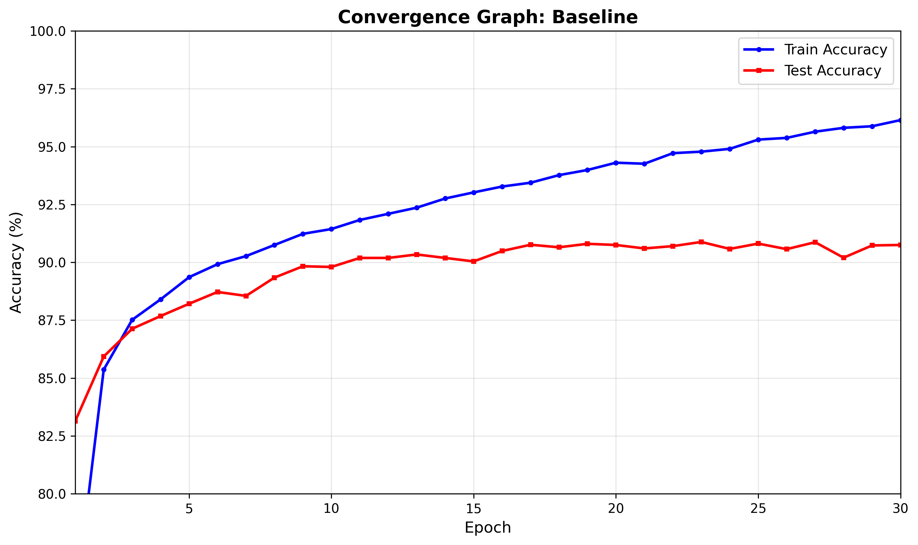
The baseline model converges quickly: training accuracy jumps from ~80% to above 90% within the first few epochs and then slowly approaches ≈96% by epoch 30. Test accuracy rises to around 90–91% and then stabilizes.
There is a consistent train–test gap of roughly 5–6 percentage points, which indicates some overfitting, but not severe. This setup already achieves around 90%+ test accuracy without any regularization.

Batch Normalization
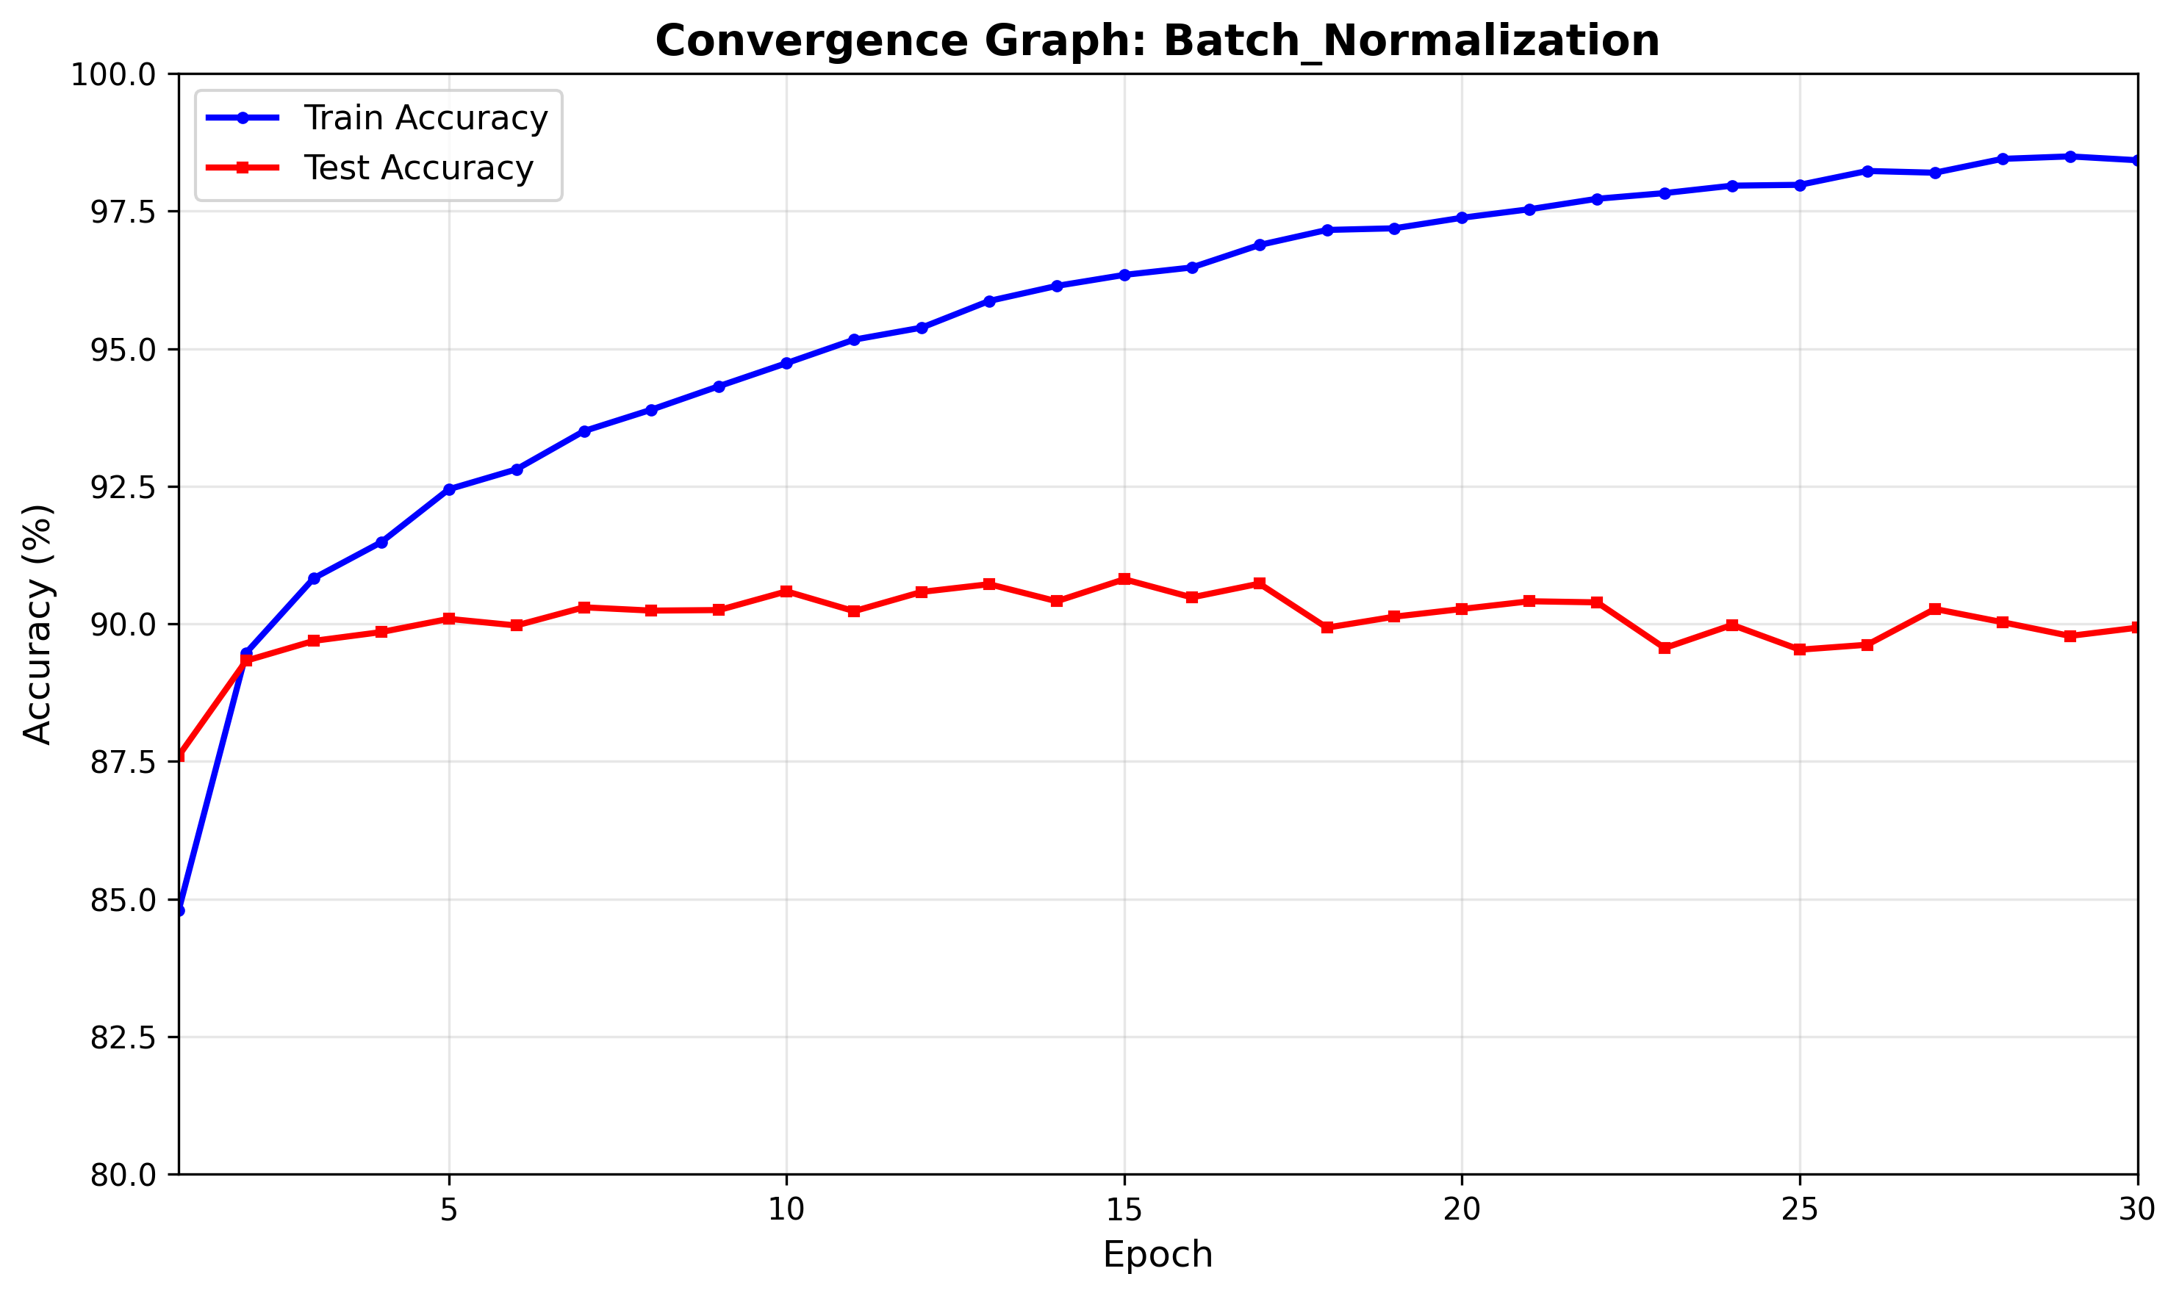
With batch normalization, training converges faster and to a higher value: the train curve reaches above 90% within ~3 epochs and ends close to 98–99%. This shows that BN makes optimization easier and stabilizes the gradients.
However, the test accuracy does not improve accordingly. It stays around ~90% and is slightly below or comparable to the baseline across most epochs, despite the much higher training accuracy. The train–test gap is now even larger.
In conclusion, this setting (relatively small LeNet-5 on a not-too-hard dataset), BN mainly helps optimization, not generalization. It allows the network to fit the training data better but does not translate into noticeably higher test accuracy; if anything, it slightly increases overfitting.

Dropout
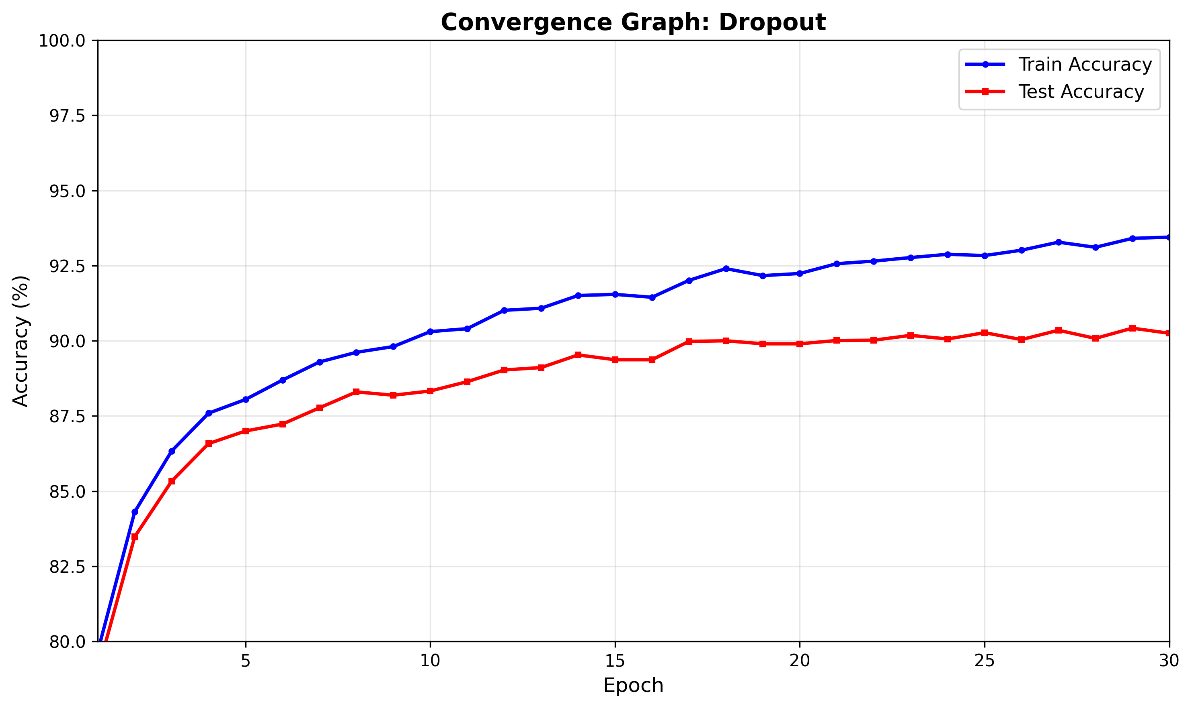
With dropout, the training accuracy is consistently lower than the baseline, ending around ≈93–94% instead of ≈96%. This is expected: randomly dropping units during training makes the effective model noisier and harder to fit perfectly.
The test accuracy, however, is very similar to the baseline (around 90–91%), sometimes slightly below but with a smaller gap between train and test. The curves are smoother, and the gap is reduced from ~5–6 percentage points (baseline) to only ~3–4.
In conclusion: dropout works as intended as a regularizer. It limits the network’s capacity to overfit the training set (lower train accuracy) while keeping test accuracy essentially unchanged, slightly improving the generalization gap.

Weight Decay (L2)
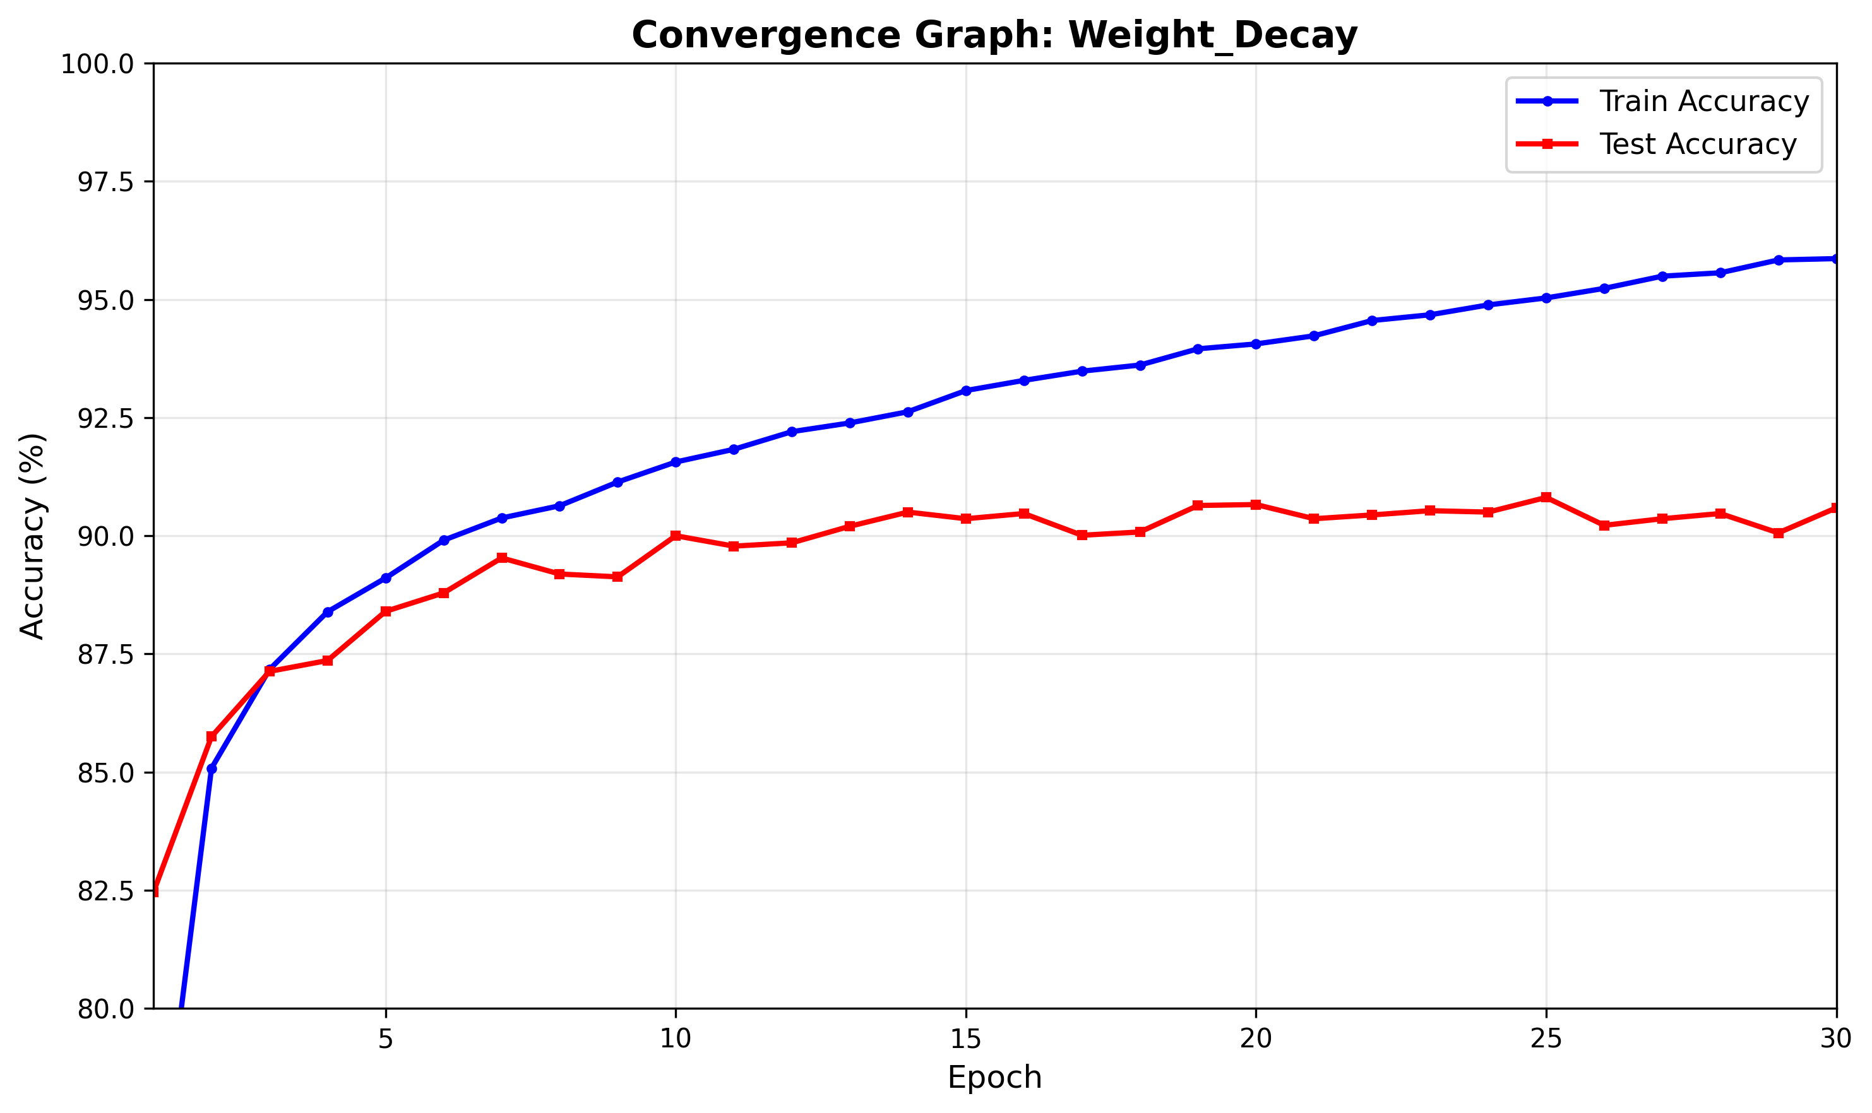
With weight decay, the training curve is close to the baseline but saturates a bit lower (≈95–96% instead of ≈96+%). The test accuracy is again around 90–91%, very similar to or marginally better than the baseline, and the train–test gap is slightly smaller.
Because L2 penalizes large weights, it discourages overly complex solutions and pushes the model toward smoother decision boundaries. In the graphs, this shows up as:
- Slightly reduced training accuracy compared to baseline.
- Test accuracy that is comparable to the best configuration and at least as stable as the baseline.
In conclusion: weight decay provides mild regularization. It does not dramatically change performance, but it slightly reduces overfitting without hurting test accuracy.

Overall comparison
- All four models reach very similar test accuracies (~90–91%). None of the techniques dramatically outperforms the others in terms of final test accuracy on Fashion-MNIST with this architecture.
- Batch normalization gives the fastest and highest training accuracy but does not improve test accuracy; it mainly helps optimization.
- Dropout and weight decay both act as true regularizers: they lower training accuracy yet keep test accuracy roughly the same as the baseline and slightly reduce the generalization gap.
- Since the baseline already generalizes well on this task, the main effect of the regularization methods is to change the trade-off between train accuracy, test accuracy and overfitting, rather than to boost test performance by several percentage points.
In summary, on this relatively small LeNet-5/Fashion-MNIST experiment, batch normalization improves convergence speed and training performance, while dropout and weight decay primarily control overfitting. The test accuracy remains around 90% across all configurations, showing that the problem is already well-posed and that regularization provides more subtle improvements in robustness rather than dramatic gains in accuracy.

